Hurdle Placement and Height Comparison – Indoor Meets

Organization/Age Group Distance Number Height To 1st Between Last to Finish
WOMEN
USATF 50 4 33” 13 m 8.5 m 11.5 m
High School 55 5 33” 13 m 8.5 m 8 m
High School 60 5 33” 13 m 8.5 m 13 m
NCAA, USATF 55 5 33” 13 m 8.5 m 8 m
NCAA, USATF 60 5 33” 13 m 8.5 m 13 m
GIRLS YOUTH USATF
Girls 11-12 50 4 30” 12 m 7.5 m 15.5 m
Girls 11-12 55 5 30” 12 m 7.5 m 13 m
Girls 11-12 60 5 30” 12 m 7.5 m 18 m
Girls 13-14 55 5 30” 13 m 8.5 m 8 m
Girls 13-14 60 5 30” 13 m 8.5 m 13 m
Girls 15-16/Women 17-18 55 5 33” 13 m 8.5 m 8. m
Girls 15-16/Women 17-18 60 5 33” 13 m 8.5 m 13 m
MASTERS WOMEN
25-39 60 5 33” 13 m 8.5 m 13 m
40-49 60 5 30” 12 m 8 m 16 m
50-59 60 5 30” 12 m 7 m 20 m
60+ 60 5 27” 12 m 7 m 20 m

Hurdle Placement and Height Comparison – Indoor Meets

Organization/Age Group Distance Number Height To 1st Between Last to Finish
MEN
USATF 50 4 42” 13.72 m 9.14 m 8.86 m
High School 55 5 39” 13.72 m 9.14 m 4.72 m
High School 60 5 39” 13.72 m 9.14 m 9.72 m
NCAA, USATF 55 5 42” 13.72 m 9.14 m 4.72 m
NCAA, USATF 60 5 42” 13.72 m 9.14 m 9.72 m
BOYS YOUTH USATF
Boys 11-12 50 4 30” 12 m 7.5 m 15.5 m
Boys 11-12 55 5 30” 12 m 7.5 m 13 m
Boys 11-12 60 5 30” 12 m 7.5 m 18 m
Boys 13-14 55 5 33” 13 m 8.5 m 8 m
Boys 13-14 60 5 33” 13 m 8.5 m 13 m
Boys 15-16/Men 17-18 55 5 39” 13.72 m 9.14 m 4.72 m
Boys 15-16/Men 17-18 60 5 39” 13.72 m 9.14 m 9.72 m
MASTERS MEN
25-49 60 5 39” 13.72 m 9.14 m 9.72 m
50-59 60 5 36” 13.00 m 8.50 m 13.00 m
60-69 60 5 33” 12.00 m 8.00 m 16.00 m
70-79 60 5 30” 12.00 m 7.00 m 20.00 m
80+ 60 5 27” 12.00 m 7.00 m 20.00 m

Placements of Cones at the Breakline and for Alley Starts

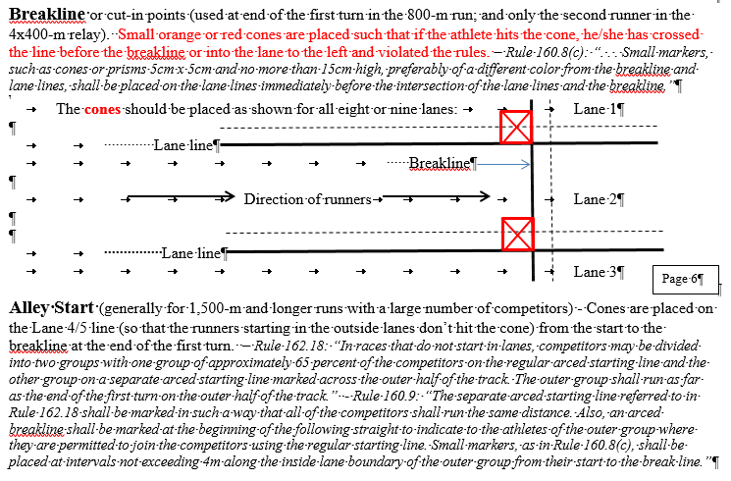
Placements of Hurdles Relative to Track Markings
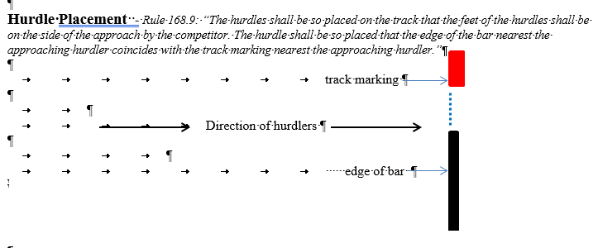

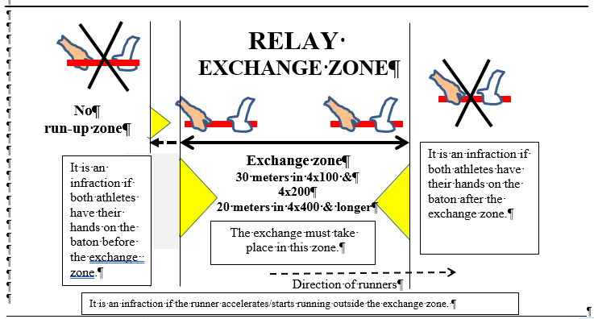
20 meters for most
indoor exchanges
Running on the curve – Stepping On But Not Over the Line Once is OK
(USATF Rules 163.5(d, e & f) and NCAA Rule 7-5.2b, new for 2025-2026 for compliance with World Athletics)

Umpires must write an incident report if an athlete steps on, but not over, the inside line (illustrated below with the red and green shoes – middle and right-hand athlete in the left-hand diagram) in races run in lanes. If this is done only once during the race, it will not result in a disqualification.

If the athlete steps on, but not over, the inside line or curb twice during the race (regardless of whether the second step is consecutive), the Referee will disqualify the athlete. For example, the infraction could occur once on the first turn and a second time on the second turn (as seen by two umpires).

For USATF Youth, this applies only to the heat in which the incident occurs.

For USATF open/senior and masters, if the same athlete (or relay team) steps on, but not over, the inside line a second time in any round of the same race (e.g., semi-final and final), the Referee will disqualify the athlete or relay team.

If an athlete steps completely over the inside line (illustrated below with the blue shoes – far left-hand athlete in the left diagram), this one step over the line results in a disqualification. If the athlete in Lane 1 steps completely over the curb in a race run in lanes, this one step over the curb results in a disqualification.

In races run not in lanes, if an athlete steps over the curb once (illustrated with the red shoe in the right-hand diagram), it will not result in a disqualification. However, if this occurs twice, the Referee will disqualify the athlete or relay team.

If the athlete gains a material advantage by stepping on the inside line on the curve or over the curb, it will result in a disqualification.

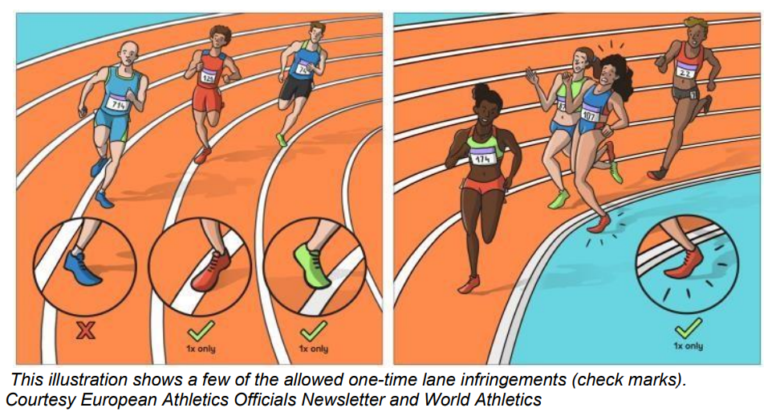

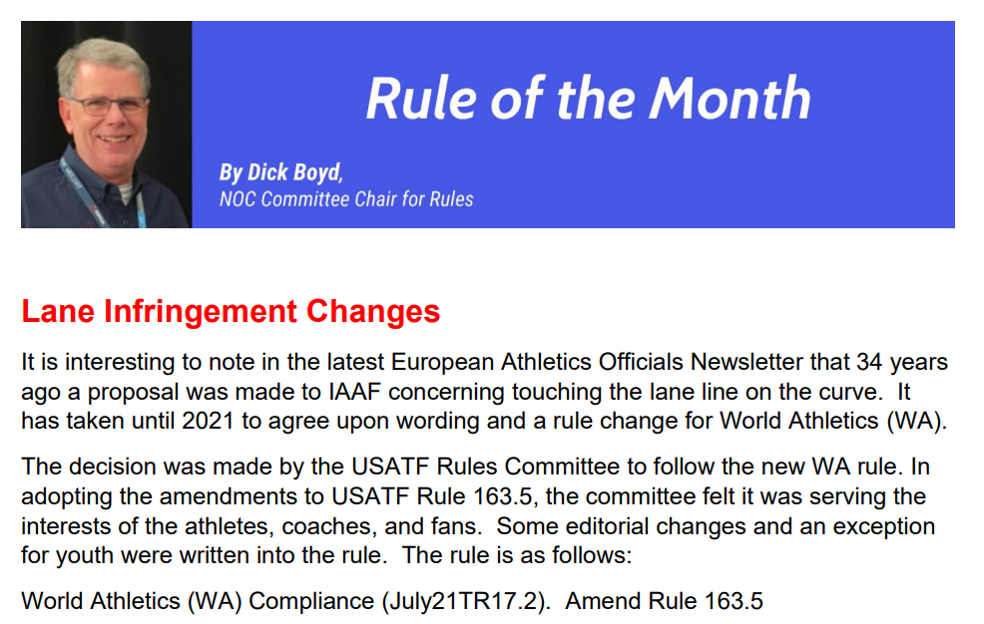
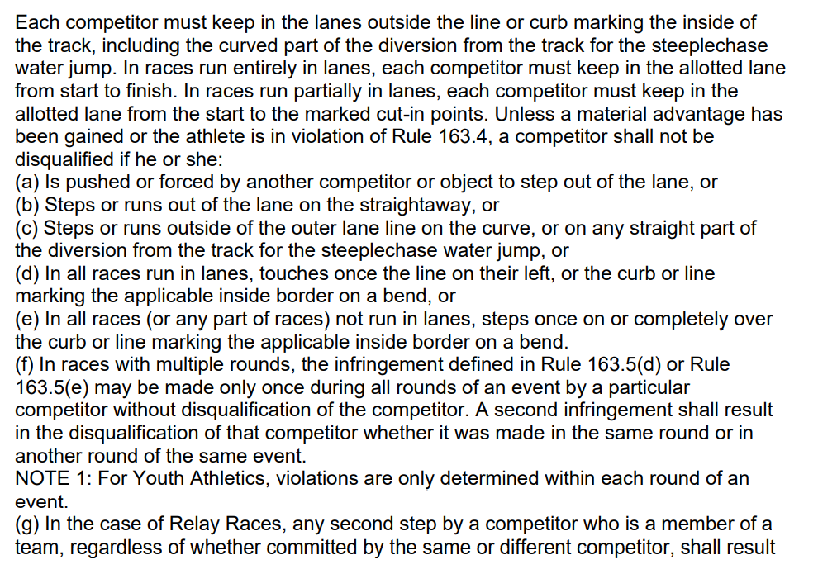
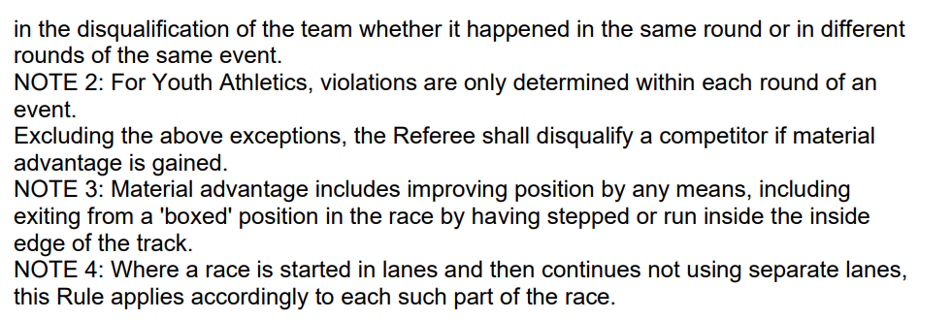
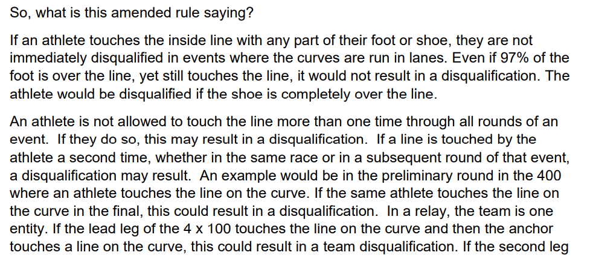
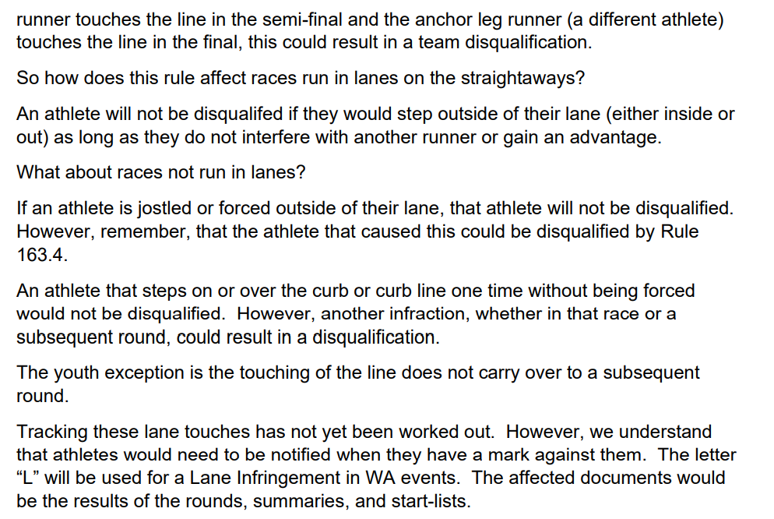
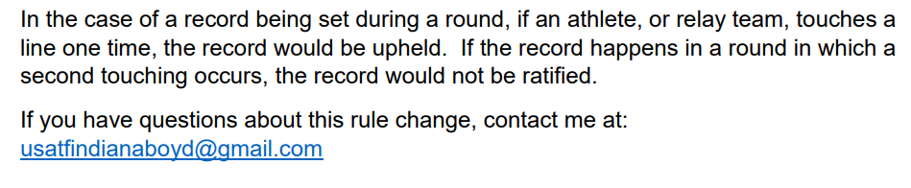
January 2022

Common Infractions – Indoor

[USATF Rule Numbers in brackets and yellow; NCAA rules in blue; NFHS rules with no highlight]

Hurdle Infractions:
Didn’t jump each hurdle (ran around or hand pushed over) [168.3] (NFHS 5.14.1.a,d&e) {NCAA 7.6.2.b}
Foot or leg below top of hurdle (hooks hurdle) [168.3(a)] [SC 169.4(b)] (NFHS 5.14.1.c) {NCAA 7.6.2.a}
Displaces hurdle by hand, torso or front side of lead lower leg [168.3(b)] (NFHS 5.14.1.b)
Deliberately knocks down any hurdle {NCAA 7.6.2.c}
Deliberately knocks down any hurdle by hand (NFHS 5.14.1.b) {NCAA 7.6.2.d}
Displaces a hurdle such that another competitor is obstructed [168.3(c)] (NFHS 5.14.1.f)
Flagrantly impedes another runner {NCAA 7.5.2.a} (NFHS 5.14.1.f)
Runs over a hurdle not in the assigned lane (NFHS 5.14.1.d)

Interference – who did it and who was impacted?
Jostled, ran across, or obstructed so as to impede another competitor [163.4] (NFHS 5.9.1) {NCAA 7.5.3.b & e}
Cuts in front of another runner without proper clearance or one full stride on the curved line start {NCAA 7.5.3.a}
Tries or forces a way between two leading runners and makes direct contact so as to impede {NCAA 7.5.3.e}
Flagrantly impedes another runner {NCAA 7.5.2.a}

Assistance – who provided it to whom? [144.2] (NFHS 4.6.5) {NCAA 14.3}
Pacing by persons not participating or lapped or about to be lapped [144.3(a)] (NFHS 4.6.5.b) {NCAA 14.3.a.4}
Possession or use by athlete of video, audio, or communication device [144.3(b)] (NFHS 4.6.5.f) {NCAA 14.3.a.1}
Aided by technology or appliance [144.3(c)] (NFHS 4.6.5.d&f) {NCAA 14.3.a.2}
Use of a mechanical aid [144.3(d)] (NFHS 4.6.5.f)
Receiving advice or other support from an official [144.3(e)].
Receiving assistance from another competitor [144.3(f)]. (NFHS 4.6.5.g&h) {NCAA 14.3.1}
Personal assistance marker on the running surface or beside it [163.2] {NCAA 14.3.a.5}, except for check marks for relays
[170.5 – 1 piece of self-adhesive tape, maximum 5cm x 40cm, if allowed by Meet Management]
No check marks for college {NCAA 7.7.4}
Competitors joining hands during the race (NFHS 4.6.5.c)
Coaching a competitor from a restricted area (NFHS 4.6.5.e)

Lane Violations:
USATF & NCAA: 1 step of either foot over inside line (curb for Lane 1) on the curve [163.5]. {NCAA 7.5.2.b/7.5.3.g}
Note: One step, but not two, on but not over the line is OK. Umpires write up one step on line [163.5(d)&(f)]
NFHS: 3 consecutive steps of any feet (5.12.1.a/5.13.2)
Cut in before break line [163.5] (NFHS 5.12.1.e) {NCAA 7.5.2.d}
Did not finish in correct lane [163.5] (NFHS 5.12.1.d) {NCAA 7.5.2.c}
Didn’t run in direct line on final straightaway, unless another competitor was in path [163.3]
Veers to right or left to flagrantly impede a challenging runner or forces the other to run a greater distance {NCAA 7.5.3.c}

Relay Violations:
Exchanged baton before or after zone [170.18] (NFHS 5.10.7) {NCAA 7.8.c}
Accelerated before zone [170.13] (NFHS 5.10.9) {NCAA 7.8.i}
Incorrect recovery of dropped baton [170.16] (NFHS 5.10.7) {NCAA 7.7.5 & 7.8.d}
Baton thrown following finishing (NFHS 5.11.2)
Impeded/did not maintain lane position [170.19] (NFHS 5.10.4&8) {NCAA 7.8.g&h}
Assisted outgoing runner by pushing [170.20] (NFHS 5.11.1)
Baton not carried by hand [170.16] (NFHS 5.10.6) {NCAA 7.8.e}
Team members not identifiable as part of the team [170.25] (NFHS 4.3.2.a) {NCAA 6.4.1.1 & 6.4.2.a&b}
Team member runs more than one leg {NCAA 7.8.j}
Didn’t run the specified relay leg distance {NCAA 7.8.k}

Failure to participate/report [142.3 & 142.4], except youth [302.2(g)] (NFHS 4.1.3) {NCAA 14.2.a&b}

Left track voluntarily and returned [163.6(a)] {NCAA 7.5.3.d}

Unsporting conduct [125.9] (NFHS 4.6.1) {NCAA 14.1}

Unacceptable conduct (NFHS 4.6.2)

Indoor Order of Events

Indoor Combined Events

Heptathlon – Men Pentathlon – Men Pentathlon - Women
First Day Second Day 60m* Hurdles 60m* Hurdles
60m* 60m* Hurdles Long Jump High Jump
Long Jump Pole Vault Shot Put Shot Put
Shot Put 1000m High Jump Long Jump
High Jump 1000m 800m

** NCAA allows for 55m & 55m Hurdles instead of 60m. USATF requires 60m.

NCAA, Rule 5.3 – Standard Order of Events
Mile
60m Hurdles
400m
60m
800m
200m
3000m
4x400 Relay
Distance Medley Relay (1200,400,800,1600)

