———————————————————————————————————————————————————————————————————————————————————————————————————————————————————————————————————————
Umpire’s Incident/Infraction Report Meet/Location: _____________ Date______Time:___________

Athlete/# ___________ Athlete’s Team/Uniform ____________________________ Division: Women / Men

Event: 55m 60m 200m 300m 400m 600m 800m 1000m 1500m 1600m Mile 3000m Race Walk: 1500m 1600m Mile 3000m

55m Hurdles 60m Hurdles 4x200m Relay 4x400m Relay 4x800m Relay Distance Medley Relay (1200, 400, 800, 1600)

Other _____________________________________ Age Group________ Heat: 1 2 3 4 5 6 7 8 9 10 Final
———————————————————————————————————————————————————————————————————————————————————————————————————————————————————————————————————————
Relay Passing/Exchange Zone Infraction □ Illegal recovery of dropped baton │ Other Infractions
│
Lane: 1 2 3 4 5 6 □ Accelerated outside zone │ Gained advantage/got assistance
│
Athlete passed baton _____ meters before / after Exchange Zone 1st 2nd 3rd │ Unsportsmanlike conduct
———————————————————————————————————————————————————————————————————————————————————————————————————————————————————————————————————————
Lane Infraction □ Athlete in Lane ___cut in before the break line. │ Athlete Left Track/Course
│
Lane: 1 2 3 4 5 6 │ Did not finish on lap # ___
│
Ran inside of 1st / 2nd turn on / over line for at least ___ consecutive steps into Lane:____ │ Gained advantage after returned
———————————————————————————————————————————————————————————————————————————————————————————————————————————————————————————————————————
Interference (impeding, obstructing, veering, jostling, tripping) – Who was impacted?
———————————————————————————————————————————————————————————————————————————————————————————————————————————————————————————————————————
Umpire’s Name _____________________________ Umpire’s Signature ______________________________

Head Umpire’s Name ________________________ Head Umpire’s Signature __________________________

Details of the incident/infraction and the Referee’s decision are written on the other side.
———————————————————————————————————————————————————————————————————————————————————————————————————————————————————————————————————————

———————————————————————————————————————————————————————————————————————————————————————————————————————————————————————————————————————
Umpire’s Incident/Infraction Report Meet/Location: _____________ Date______Time:___________

Athlete/# ___________ Athlete’s Team/Uniform ____________________________ Division: Women / Men

Event: 55m 60m 200m 300m 400m 600m 800m 1000m 1500m 1600m Mile 3000m Race Walk: 1500m 1600m Mile 3000m

55m Hurdles 60m Hurdles 4x200m Relay 4x400m Relay 4x800m Relay Distance Medley Relay (1200, 400, 800, 1600)

Other _____________________________________ Age Group________ Heat: 1 2 3 4 5 6 7 8 9 10 Final
———————————————————————————————————————————————————————————————————————————————————————————————————————————————————————————————————————
Relay Passing/Exchange Zone Infraction □ Illegal recovery of dropped baton │ Other Infractions
│
Lane: 1 2 3 4 5 6 □ Accelerated outside zone │ Gained advantage/got assistance
│
Athlete passed baton _____ meters before / after Exchange Zone 1st 2nd 3rd │ Unsportsmanlike conduct
———————————————————————————————————————————————————————————————————————————————————————————————————————————————————————————————————————
Lane Infraction □ Athlete in Lane ___cut in before the break line. │ Athlete Left Track/Course
│
Lane: 1 2 3 4 5 6 │ Did not finish on lap # ___
│
Ran inside of 1st / 2nd turn on / over line for at least ___ consecutive steps into Lane:____ │ Gained advantage after returned
———————————————————————————————————————————————————————————————————————————————————————————————————————————————————————————————————————
Interference (impeding, obstructing, veering, jostling, tripping) – Who was impacted?
———————————————————————————————————————————————————————————————————————————————————————————————————————————————————————————————————————
Umpire’s Name _____________________________ Umpire’s Signature ______________________________

Head Umpire’s Name ________________________ Head Umpire’s Signature __________________________

Details of the incident/infraction and the Referee’s decision are written on the other side.
———————————————————————————————————————————————————————————————————————————————————————————————————————————————————————————————————————

———————————————————————————————————————————————————————————————————————————————————————————————————————————————————————————————————————
Umpire’s Incident/Infraction Report Meet/Location: _____________ Date______Time:___________

Athlete/# ___________ Athlete’s Team/Uniform ____________________________ Division: Women / Men

Event: 55m 60m 200m 300m 400m 600m 800m 1000m 1500m 1600m Mile 3000m Race Walk: 1500m 1600m Mile 3000m

55m Hurdles 60m Hurdles 4x200m Relay 4x400m Relay 4x800m Relay Distance Medley Relay (1200, 400, 800, 1600)

Other _____________________________________ Age Group________ Heat: 1 2 3 4 5 6 7 8 9 10 Final
———————————————————————————————————————————————————————————————————————————————————————————————————————————————————————————————————————
Relay Passing/Exchange Zone Infraction □ Illegal recovery of dropped baton │ Other Infractions
│
Lane: 1 2 3 4 5 6 □ Accelerated outside zone │ Gained advantage/got assistance
│
Athlete passed baton _____ meters before / after Exchange Zone 1st 2nd 3rd │ Unsportsmanlike conduct
———————————————————————————————————————————————————————————————————————————————————————————————————————————————————————————————————————
Lane Infraction □ Athlete in Lane ___cut in before the break line. │ Athlete Left Track/Course
│
Lane: 1 2 3 4 5 6 │ Did not finish on lap # ___
│
Ran inside of 1st / 2nd turn on / over line for at least ___ consecutive steps into Lane:____ │ Gained advantage after returned
———————————————————————————————————————————————————————————————————————————————————————————————————————————————————————————————————————
Interference (impeding, obstructing, veering, jostling, tripping) – Who was impacted?
———————————————————————————————————————————————————————————————————————————————————————————————————————————————————————————————————————
Umpire’s Name _____________________________ Umpire’s Signature ______________________________

Head Umpire’s Name ________________________ Head Umpire’s Signature __________________________

Details of the incident/infraction and the Referee’s decision are written on the other side.
———————————————————————————————————————————————————————————————————————————————————————————————————————————————————————————————————————
———————————————————————————————————————————————————————————————————————————————————————————————————————————————————————————————————————
Details of the Incident/Infraction
Describe:

Referee’s Decision Rule
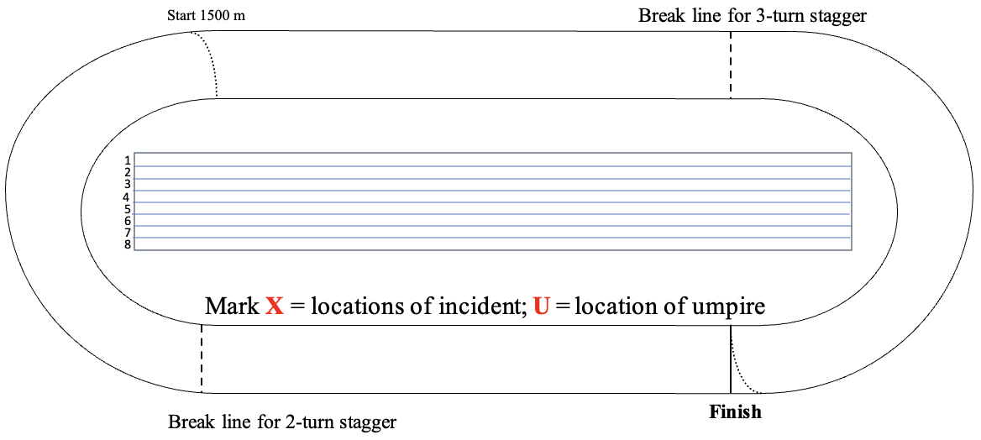

USATF-Pacific 9/18/24

Referee’s Name _________________________________ Referee’s Signature __________________________

———————————————————————————————————————————————————————————————————————————————————————————————————————————————————————————————————————

———————————————————————————————————————————————————————————————————————————————————————————————————————————————————————————————————————
Details of the Incident/Infraction
Describe:

Referee’s Decision Rule

USATF-Pacific 9/18/24

Referee’s Name _________________________________ Referee’s Signature __________________________

———————————————————————————————————————————————————————————————————————————————————————————————————————————————————————————————————————

———————————————————————————————————————————————————————————————————————————————————————————————————————————————————————————————————————
Details of the Incident/Infraction
Describe:

Referee’s Decision Rule

USATF-Pacific 9/18/24

Referee’s Name _________________________________ Referee’s Signature __________________________

