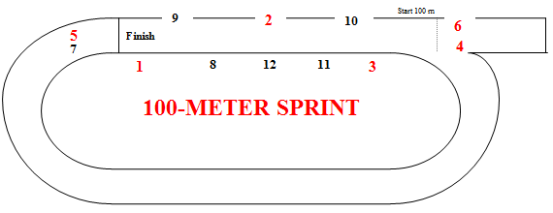

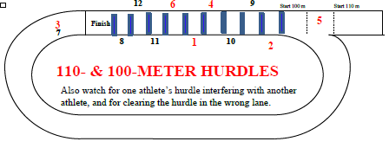

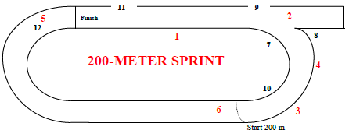

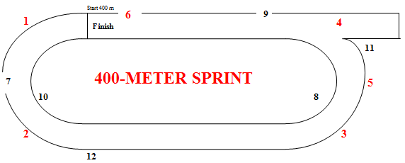

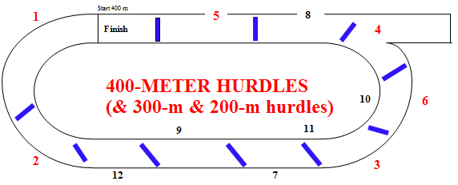

**2**

**300- & 200-METER HURDLES**

**Umpires’ Positions**

NNTOA v.1Nov2020

**Hurdle Infractions**:

Foot or leg below top of hurdle (hooks hurdle) [Rule 5.14.2.c]

Didn’t jump each hurdle (ran around or hand pushed over) [Rule 5.14.2.a.b.e]

Deliberately knocked down hurdle [Rule 5.14.2.a]

Didn’t stay in lane (interfered {with whom?} or shortened race) [Rule 5.14.2.f]

Runs over hurdle not in the assigned lane [Rule 5.14.2.d]

**Interference** – who did it and who was impacted?

Jostled, ran across, or obstructed so as to impede another competitor [Rule 5.9.1]

**Assistance** – who provided it to whom?

Pacing by persons not participating in the event [Rule 4.6.5.b]

Possession or use by athlete of video, audio, or communication device [4.6.5.f]

Aided by technology or appliance [Rule 4.6.5.d & f]

Receiving assistance from another competitor [Rule 4.6.5.g]

Competitors joining or grasping hands with each other during a race [4.6.5.c]

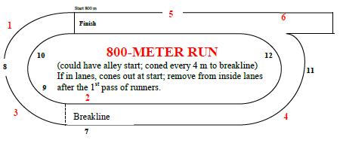

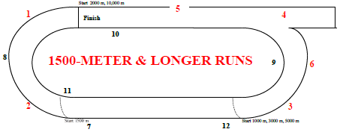

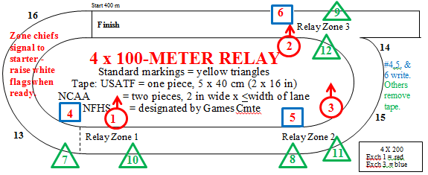

Tape – designated by Games Committee

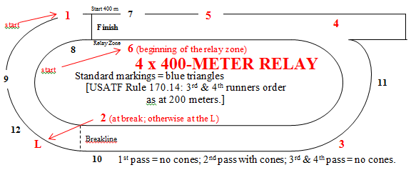

Standard markings = red for 1st & 2nd exchanges; yellow for 3rd

**4 x 200-METER RELAY**

Relay Zone 2

Relay Zones 1 & 3

**& Common Infractions**

[Rule 170.5]

**Lane Violations**:

3 or more consecutive steps of any feet inside lane line on curve [Rule 5.12.1.a]

Cut in before break line with one or more steps [Rule 5.12.1.e]

Did not finish in correct lane [Rule 5.12.1.d]

**Failure to participate** (after clerk closes entries in a run or judge starts field event)

[Rule 4.1.3]

**Unsporting conduct** (disrespectfully addressing an official; flagrant behavior, intentional contact, taunting, criticizing, or using profanity directed toward someone)

**Unacceptable conduct** (willful failure to follow official’s directions, using profanity not directed to someone else, action that brings discredit to individual or school)

[Rules 4.6.1 & 4.6.2]

**Relay Violations**: see back of this page

**SUBMIT WRITTEN INCIDENT/INFRACTION REPORT TO THE CHIEF UMPIRE, WHO SUBMITS IT TO THE REFEREE**.

**Hurdle Placement and Height Comparison – Outdoor Meets** - Rule 5.3.7

Group Distance Number Height To 1st Between Last to Finish

Standard color

**BOYS**

Junior High 110 10 33” 13.72 m 9.14 m 14.02 m **BLUE**

**High School 110 10 39” 13.72 m 9.14 m 14.02 m**  **BLUE**

Junior High 200 5 30” 50 m 35 m 10 m **RED**

**High School 300 8 36” 45 m 35 m 10 m**  **RED**

———————————————————————————————————————————————————————————————————————————————————————————————————————————————————————————————————————

**GIRLS**

Junior High 100 10 30” 13 m 8.5 m 10.5 m YELLOW

**High School 100 10 33” 13 m 8.5 m 10.5 m**  YELLOW

Junior High 200 5 30” 50 m 35 m 10 m **RED**

**High School 300 8 30” 45 m 35 m 10 m**  **RED**

**Placements of Hurdles Relative to Track Markings**

(NFHS Officials Manual: “In setting up hurdles, align the crossbar exactly over the mark on the track.”

track marking

Direction of hurdlers

edge of crossbar

———————————————————————————————————————————————————————————————————————————————————————————————————————————————————————————————————————

**Relay Exchange Zones** **Standard color for triangles indicating the zones**

4 x 100-meters (400 meters) YELLOW Δ

4 x 200 meters (800 meters) **RED Δ** for 1st and 2nd exchanges (RED/YELLOW in Lane 1)

YELLOW Δ for 3rd exchange zone (same as 4 x 100)

4 x 400 meters (1600 meters) **BLUE Δ** (staggered for 1st exchange zone)

4 x 800 meters (3200 meters) **GREEN Δ**

**Common Relay Infractions**

Exchanged before or after the relay exchange zone (both runners have hands on the baton outside the zone) Rule 5.10.6 & 7

Outgoing runner starts running before the exchange zone – Rule 5.10.9

Incorrect recovery of dropped baton – Rule 5.10.7

Interference/impeded other runners – Rule 5.10.4, 7 & 8 Baton not passed in the assigned lane [Rule 5.12.1.d]

Incoming runner assisted the outgoing runner by pushing them – Rule 5.11.1

Baton not carried by hand – Rule 5.10.6

Throwing the baton following the finishing of the relay race – Rule 5.11.2

———————————————————————————————————————————————————————————————————————————————————————————————————————————————————————————————————————

**Break line** (used at end of the first turn in the 800-m run; and only the second runner in the 4x400-m relay). Small orange or red cones are placed such that if the athlete hits the cone, he/she has crossed the line before the break line or into the lane to the left and violated the rules. – *Rules 5.12.1.e & 5.12.2*

The **cones** should be placed as shown for all eight or nine lanes: Lane 1

Lane line

Break line

Direction of runners Lane 2

Lane line

Lane 3

———————————————————————————————————————————————————————————————————————————————————————————————————————————————————————————————————————