**Break line #1** for 2nd runner in 4x200 with 3-turn stagger and 1,500m with 2-turn stagger

1,500m START

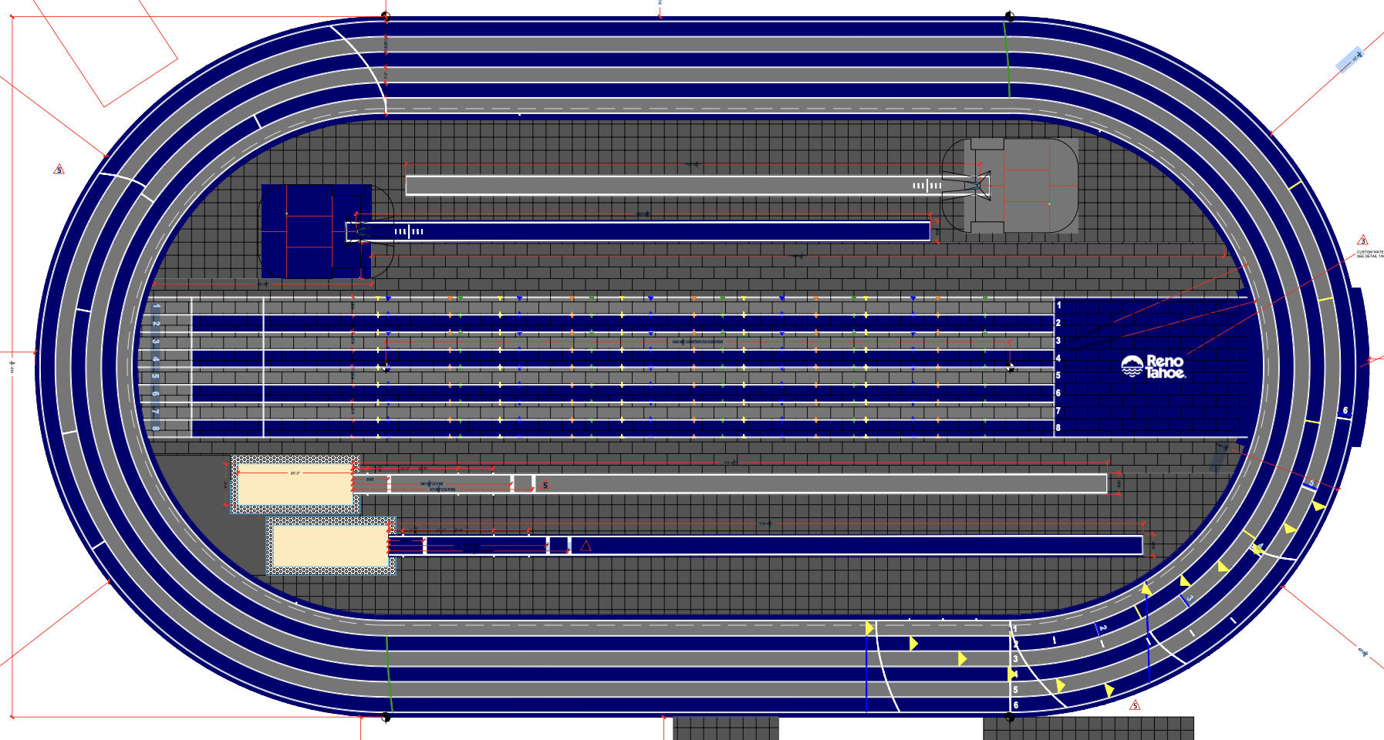

End of 1st exchange in 4x200

Alley for 1,500m

End of exchange, Lane 1

Alley for >800

Alley for Mile

Beginning of exchange zone for 4x200

Waterfall START for >800m

Mile START

**Break line #2** for most races with 2-turn stagger (>400m and first runner in 4x400, 4x800, and Distance Medley Relay = 1200, 400, 800, 1600). NOTE: 1,500 m uses Break line #1.

FINISH

START LINES for RACES with STAGGERS

Short White = 1-turn stagger (rarely used)

Blue = 2-turn stagger (>400m and relays >400m per runner)

Yellow = 3-turn stagger (4x200 USATF)

**Sprints and Hurdles**

FINISH

55-m START

60-m START

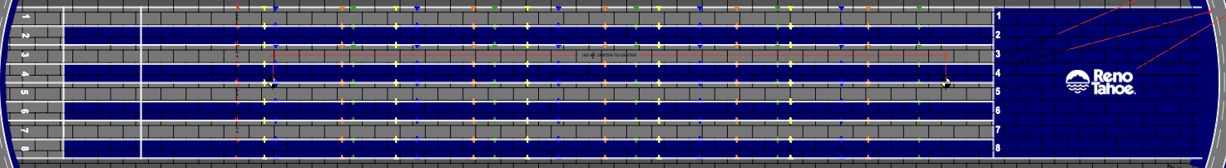

Hurdle

Marking To 1st. Between To 2nd To 3rd To 4th To 5th Last to Finish Total Groups (Masters in gray)

Yellow 13 8.5 21.5 30.0 38.5 47.0 13.0 60 m Women(33”), G15-16(33”), YW17-18(33”)

Note: effective June 1, 2025, 36” for B13-14 B13-14(36”), G13-14(30”), W25-39(33”)

M50-59(36”)

Blue 13.72 9.14 22.86 32.0 41.14 50.28 9.72 60 m Men(42”), B15-16(39”) & YM17-18(39”)

M25-49(39”)

A=Pink 11 6.0 17.0 23.0 29.0 35.0 25.0 60 m W70+(27”), M80+(27”)

B=Purple 12 7.0 19.0 26.0 33.0 40.0 20.0 60 m M70-79&W50-59(30”), W60-69(27”)

C=Red 12 7.5 19.5 27.0 34.5 42.0 18.0 60 m B11-12(30”), G11-12(30”)

D=Gray 12 8.0 20.0 28.0 36.0 44.0 16.0 60 m M60-69(33”) & W40-49(30”)

E=Beige 12 7.5 19.5 27.0 34.5 42.0 13.0 55 m B11-12(30”), G11-12(30”)

Orange 13 8.5 21.5 30.0 38.5 47.0 8.0 55 m Women(33”), G15-16(33”), YW17-18(33”)

B13-14(33”), G13-14(30”)

Green 13.72 9.14 22.86 32.0 41.14 50.28 4.72 55 m Men(42”), B15-16(39”) & YM17-18(39”)

NOTE: B13-14 remains 33” until June 1, 2025.

NOTE: Hurdles A=Pink go into effect January 1, 2026. Until then, these old Masters use Hurdles B=Purple at 27”.

MARKINGS measured from the 60-meter START LINE (adding 5 meters to each 55-meter mark)

Hurdle

Marking To 1st. Between To 2nd To 3rd To 4th To 5th Last to Finish Total Groups (Masters in gray)

Yellow 13 8.5 21.5 30.0 38.5 47.0 13.0 60 m Women(33”), G15-16(33”), YW17-18(33”)

Note: effective June 1, 2025, 36” for B13-14 B13-14(36”), G13-14(30”), W25-39(33”)

M50-59(36”)

Blue 13.72 9.14 22.86 32.0 41.14 50.28 9.72 60 m Men(42”), B15-16(39”) & YM17-18(39”)

M25-49(39”)

A=Pink 11 6.0 17.0 23.0 29.0 35.0 25.0 60 m W70+(27”), M80+(27”)

B=Purple 12 7.0 19.0 26.0 33.0 40.0 20.0 60 m M70-79&W50-59(30”), W60-69(27”)

C=Red 12 7.5 19.5 27.0 34.5 42.0 18.0 60 m B11-12(30”), G11-12(30”)

D=Gray 12 8.0 20.0 28.0 36.0 44.0 16.0 60 m M60-69(33”) & W40-49(30”)

E=Beige 17 7.5 24.5 32.0 39.5 47.0 13.0 60~~55~~ m B11-12(30”), G11-12(30”)

Orange 18 13.5 26.5 35.0 43.5 52.0 8.0 60~~55~~ m Women(33”), G15-16(33”), YW17-18(33”)

B13-14(33”), G13-14(30”)

Green 18.72 14.14 27.86 37.0 46.14 55.28 4.72 60~~55~~ Men(42”), B15-16(39”) & YM17-18(39”)

Coincident marks are highlighted in grey.